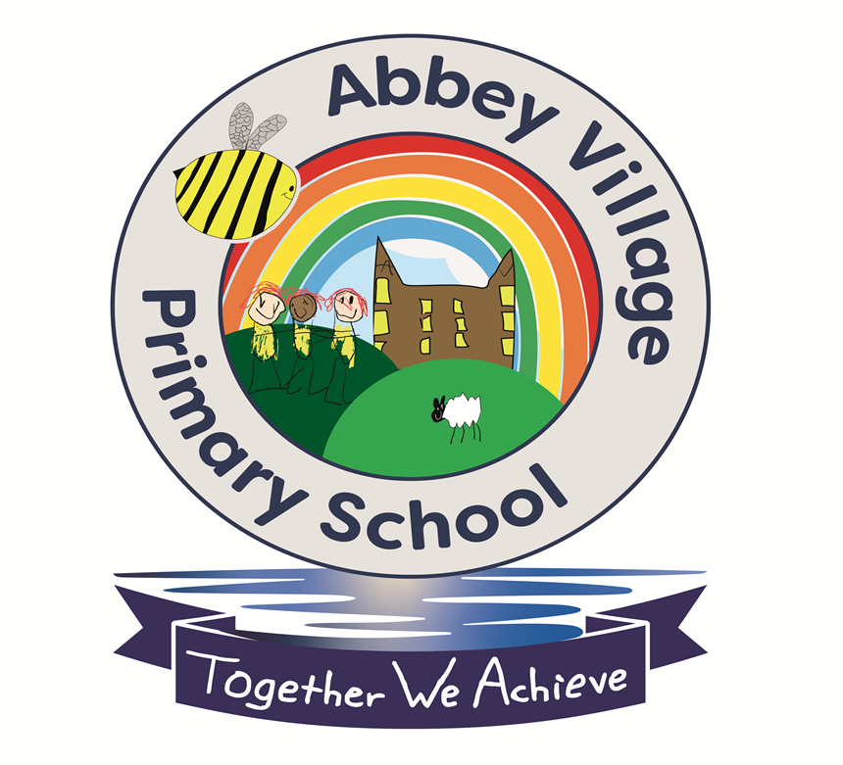
EQUALITIES POLICY

January 2025

Originally Written by Shelley Bennett- Head Teacher
January 2022 – Reviewed Annually

Agreed by Governors January 2022
Next Review Date: January 2026

EQUALITIES POLICY
Abbey Village Primary School

Aims of Policy

At Abbey Village Primary School, we are committed to ensuring a high quality education for all pupils, and to prepare pupils for full participation in society. At Abbey Village Community Primary School, we aim to develop an ethos in which diversity and difference is valued, in order to promote self- confidence, co-operation and respect for the rights of all its members. We aim to ensure that no-one is discriminated against, be they staff or pupil, on the grounds of age, class, colour, abilities, ethnic or national origin, gender, religious beliefs or sexual orientation. We ensure that all pupils have equal access to the full range of educational and other opportunities provided by the school, in order to develop their full potential. In the education we provide, we promote the principles of fairness and justice for all. We are aware that prejudice and stereotyping is caused by low self-image and ignorance. Through positive educational experiences, and support for each individual’s point of view, we aim to promote positive social attitudes and respect for all. We aim to develop a learning environment where each individual feels safe and valued. We ensure that all recruitment, employment, promotion and training systems are fair to all, and provide opportunities for everyone to achieve.
Our school aims to meet its obligations under the public sector equality duty by having due regard to the need to:
- Eliminate discrimination and other conduct that is prohibited by the Equality Act 2010
- Advance equality of opportunity between people who share a protected characteristic and people who do not share it
- Foster good relations across all characteristics – between people who share a protected characteristic and people who do not share it
Having due regard for advancing equality involves:

- Removing or minimising disadvantages suffered by people due to their protected characteristics.
- Taking steps to meet the needs of people from protected groups where these are different from the needs of other people.
- Encouraging people from protected groups to participate in public life or in other activities where their participation is disproportionately low.

- School in Context

Our school is set within a small rural village community. We are a mixed age and mixed gender school. We have the capacity to take up to 119 children on roll, our annual intake varies each year. We are a fully inclusive school and treat all staff, visitors and pupils equally regardless of their gender, race, religion, beliefs, skin colour, socio-economic background and home language. We aim to make our building as physically accessible as possible allowing for all reasonable adjustments to our historic building.

- Legislation and Guidance

This document refers to the following legislation:
- The Equality Act 2010, which introduced the public sector equality duty and protects people from discrimination
- The Equality Act 2010 (Specific Duties) Regulations 2011, which require schools to publish information to demonstrate how they are complying with the public sector equality duty and to publish equality objectives
Other supporting documents are Department for Education (DfE) guidance: The Equality Act 2010 and schools: https://assets.publishing.service.gov.uk/government/uploads/system/uploads/attachment_data/file/315587/Equality_Act_Advice_Final.pdf
and the Equality and Human Rights Commission: Technical Guidance for Schools: https://www.equalityhumanrights.com/en/publication-download/technical-guidance-schools-england

- Roles and Responsibilities

The governing board will:
- Ensure that the equality information and objectives as set out in this statement are published and communicated throughout the school, including to staff, pupils and parents, and that they are reviewed and updated at least once every four years
- Delegate responsibility for monitoring the achievement of the objectives on a daily basis to the headteacher
The equality link governor is Alison Hazlewood. They will:
Meet with the designated member of staff for equality and other relevant staff members, to discuss any issues and how these are being addressed
Ensure they’re familiar with all relevant legislation and the contents of this document
Attend appropriate equality and diversity training
Report back to the full governing board regarding any issues
The headteacher will:
Promote knowledge and understanding of the equality objectives amongst staff and pupils
Monitor success in achieving the objectives and report back to governors
All school staff are expected to have regard to this document and to work to achieve the objectives as set out in section 8. All staff will promote an inclusive and collaborative ethos in the school, challenge inappropriate language and behaviour, respond appropriately to incidents of discrimination and harassment, ensure appropriate support for children with additional needs and maintain a good level of awareness of equalities issues

All members of the school community have a responsibility to treat each other with respect, to feel valued, and to speak out if they witness or are subject to any inappropriate language or behaviour

We will take steps to ensure all visitors to the school adhere to our commitment to equality.

- Eliminating discrimination

At Abbey Village Primary School, we recognise that all members of the school and our wider community are of equal value. The school is aware of its obligations under the Equality Act 2010 and complies with non-discrimination provisions.
Where relevant, our policies include reference to the importance of avoiding discrimination and other prohibited conduct.
Staff and governors are regularly reminded of their responsibilities under the Equality Act, for example during meetings. Where this has been discussed during a meeting, it is recorded in the meeting minutes.
New staff receive training on the Equality Act as part of their induction, and all staff receive refresher training every year.
The Headteacher is responsible for monitoring equality issues, aided by our equality link governor. They regularly liaise regarding any issues and make senior leaders and governors aware of these as appropriate.

5. Advancing equality of opportunity

Removing or minimising disadvantages suffered by people which are connected to a particular characteristic they have (e.g. pupils with disabilities, or gay pupils who are being subjected to homophobic bullying)
Taking steps to meet the particular needs of people who have a particular characteristic (e.g. enabling Muslim pupils to pray at prescribed times)
Encouraging people who have a particular characteristic to participate fully in any activities (e.g. encouraging all pupils to be involved in the full range of school societies)
In fulfilling this aspect of the duty, the school will:
Publish attainment data each academic year showing how pupils with different characteristics are performing
Analyse the above data to determine strengths and areas for improvement, implement actions in response and publish this information
Make evidence available identifying improvements for specific groups (e.g. declines in incidents of homophobic or transphobic bullying)
Publish further data about any issues associated with particular protected characteristics, identifying any issues which could affect our own pupils

- Fostering good relations

As a school we believe that should treat each other with care, respect and kindness, and that strong positive relationships make a great school. We aim to foster good relations between those who share a protected characteristic and those who do not share it by:

- Continuing links with the local community and other schools to support the promotion of diversity and cultural awareness.
- School linking with Beaumont Primary School, Bolton
- Promoting tolerance, friendship and understanding of a range of religions and cultures through different aspects of our curriculum. This includes teaching in RE, citizenship and personal, social, health and economic (PSHE) education, but also activities in other curriculum areas. For example, as part of teaching and learning in English/reading, pupils will be introduced to literature from a range of cultures
- Holding assemblies dealing with relevant issues. Pupils will be encouraged to take a lead in such assemblies, and we will also invite external speakers to contribute
- Working with our local community. This includes inviting leaders of local faith groups to speak at assemblies, and organising school trips and activities based around the local community
- Encouraging and implementing initiatives to deal with tensions between different groups of pupils within the school. For example, our school council has representatives from different year groups and is formed of pupils from a range of backgrounds. All pupils are encouraged to participate in the school’s activities, such as sports clubs. We also work with parents to promote knowledge and understanding of different cultures
- We have developed links with people and groups who have specialist knowledge about particular characteristics, which helps inform and develop our approach

- Publicising the Policy and Plan

We will ensure that our Policy and Plan is made available to any stakeholder who wishes to see it. It will be held on our school website and a copy made available to any stakeholder who expresses an interest. We will ensure that this policy will be available in different formats if required and on request.

- Equality Objectives

Due to our school being within such a small rural community, we are committed at Abbey Village to further promote diversity and inclusion within our school. We will endeavour to foster links with schools from different contexts to ensure that our pupils can be prepared for life within modern Britain and truly value all people for their own unique identities, talents and beliefs.

Our Equality Objectives for 2024-2025 are:

Objective 1
To ensure the school actively promotes and prioritises raising awareness, appreciation of and celebration of diversity and protected characteristics.

Objective 2
To raise awareness of and maximise the outcomes for students with SEN or a disability.

Objective 3
To promote the importance of good attendance amongst pupils with SEN or a disability.

Objective 4
To maximise opportunities and achievement for all groups of pupils, including gender; sexuality, race and religion and those with SEN, including access to extra-curricular activities.

8 Monitoring Arrangements

We will review and update the equality information we publish at least each year to demonstrate how we are meeting the aims of the general public sector equality duty and to evidence progress made towards our equality objectives. Our objectives will be drawn up and published by the Governing Board at least every 4 years.

- Considering Equalities in Decision Making

Our school ensures it has due regard to equality considerations whenever significant decisions are made. We consider equality implications before and at the time that we develop policy and make decisions and continue to review these on a continuing basis. We keep a written record to show we have considered equality issues and asked relevant questions about the impact of our decisions on different groups in the school community

